Apothem – a calculus problem
Yue Kwok Choy
1. Apothem definition

Given a regular polygon, the apothem is the line segment from the centre to the mid-point of its side.
The word “apothem” may also refer to its length. In this article we denote this by a.
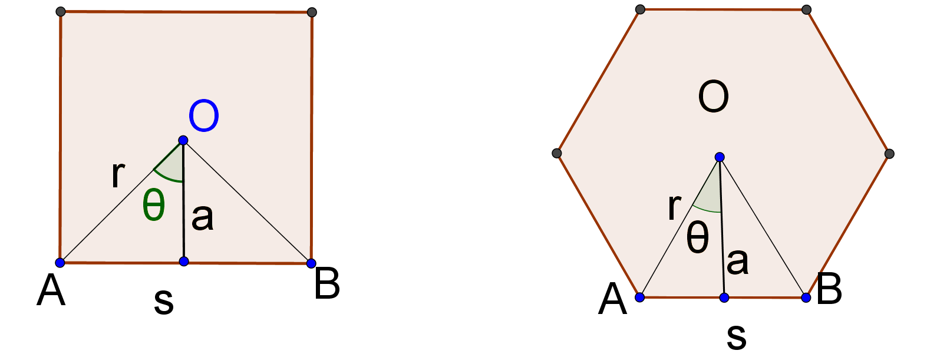
The above diagram shows the apothems of a square and a regular hexagon.
We take O to be the centre, r to be the radius of the circum-circle (a circle passing through all vertices, not drawn in the above diagrams) and θ to be the semi-central angle.

2. Apothem formulas

Let A be the area and P be the perimeter of an n-sided regular polygon with side s.
The followings are apothem formulas. These are easy geometry and trigonometry exercise for you to derive.
(a) $a=\frac{s}{2\tan{θ}}=\frac{s}{2\tan\left(\frac{π}{n}\right)}=\frac{s}{2}cos\left(\frac{π}{n}\right)$ (The semi-central angle is in radians.)
$a=\frac{s}{2\tan{θ}}=\frac{s}{2\tan\left(\frac{180°}{n}\right)}=\frac{s}{2}cos\left(\frac{180°}{n}\right)$ (The semi-central angle is in degrees.)
From now on we use only radians.
$a=\frac{s}{2}\tan\left[\frac{π\left(n-2\right)}{2n}\right]$
$a=rcos θ=rcos \left(\frac{π}{n}\right)$
(b) Area of $∆OAB=\frac{1}{2}as=a^{2}\tan{θ}=a^{2}\tan\left(\frac{π}{n}\right)$
Area of regular polygon = $A=\frac{nas}{2}=a^{2}\tan\left(\frac{π}{n}\right)=\frac{Ps}{2}$

3. Wire cutting problem

A piece of wire of length constant L is cut and bent into two pieces. One piece is bent to form a square and another to form regular hexagon. Find the minimum of the total areas of the square and the hexagon.

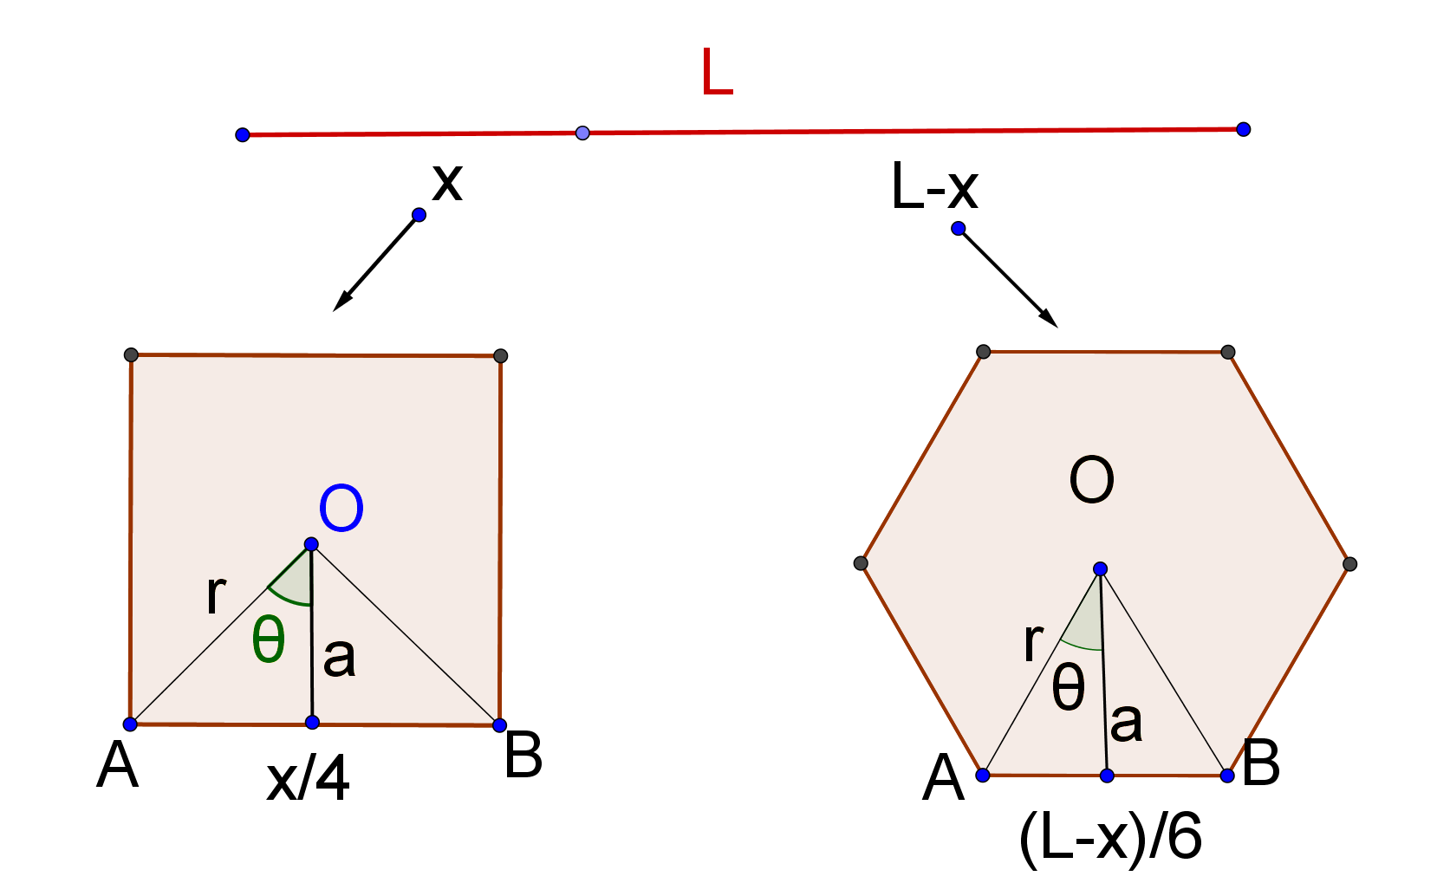

Standard Calculus Method

Let the wire is cut into two parts: x (for the square) and (L – x) (for the regular hexagon)
Area of the square = ${\left(\frac{x}{4}\right)}^{2}=\frac{x^{2}}{16}$
The hexagon can be divided into 6 equilateral triangles, one being $∆OAB$.
Area of $∆OAB=\frac{1}{2}{\left(\frac{L-x}{6}\right)}^{2}\sin{\frac{π}{3}}=\frac{1}{2}{\left(\frac{L-x}{6}\right)}^{2}\frac{\sqrt{3}}{2}$
Area of hexagon = $6×\frac{1}{2}{\left(\frac{L-x}{6}\right)}^{2}\frac{\sqrt{3}}{2}=\frac{\sqrt{3}}{24}{\left(L-x\right)}^{2}$
Total area of the square and the hexagon, $A=\frac{x^{2}}{16}+\frac{\sqrt{3}}{24}{\left(L-x\right)}^{2}$
$\frac{dA}{dx}=\frac{1}{8}x-\frac{\sqrt{3}}{24}\left[2\left(L-x\right)\right]$
For turning points, $\frac{dA}{dx}=0 ⟹\frac{1}{8}x-\frac{\sqrt{3}}{24}\left[2\left(L-x\right)\right]=0 ⟹3x-2\sqrt{3}\left(L-x\right)=0$
$∴x=\frac{2\sqrt{3}L}{3+2\sqrt{3}}=\frac{2\sqrt{3}L\left(3-2\sqrt{3}\right)}{\left(3+2\sqrt{3}\right)\left(3-2\sqrt{3}\right)}=2 \left(2-\sqrt{3}\right) L$
(Test for minimum is left for the reader.)
$A_{min}=\frac{{\left[2 \left(2-\sqrt{3}\right) L\right]}^{2}}{16}+\frac{\sqrt{3}}{24}{\left\{L-\left[2 \left(2-\sqrt{3}\right) L\right]\right\}}^{2}$ $=\frac{L^{2}}{4}-\frac{\sqrt{3} L^{2}}{8}=\frac{L^{2}}{8}\left(2-\sqrt{3}\right)$

Apothem Method

Let $A_{1},P_{1},a_{1}$ be the area, perimeter and apothem of the square respectively, and
$A_{2},P_{2},a_{2}$ be the area, perimeter and apothem of the regular hexagon respectively.

It is not too difficult to note that the apothem is proportional to the side and hence the perimeter of the polygon.
Hence $P_{1}=k_{1}a_{1}, {{ P}_{2}=k_{2}a}_{2}$
$L=k_{1}a_{1}+ {k_{2}a}_{2}$
$\frac{dL}{dx}=k_{1}\frac{{da}_{1}}{dx}+ k_{2}\frac{{da}_{2}}{dx}=0 ⟹k_{2}\frac{{da}_{2}}{dx}=-k_{1}\frac{{da}_{1}}{dx} …(1)$

$A=\frac{P_{1}a_{1}}{2}+\frac{P_{2}a_{2}}{2}=\frac{k_{1}{a_{1}}^{2}}{2}+\frac{P_{2}{a_{2}}^{2}}{2} ⟹ \frac{dA}{dx}=k_{1}a_{1}\frac{{da}_{1}}{dx}+ {k_{2}a}_{2}\frac{{da}_{2}}{dx}=k_{1}a_{1}\frac{{da}_{1}}{dx}-k_{1}a_{2}\frac{{da}_{1}}{dx}$ , by (1)
$\frac{dA}{dx}=0⟹k_{1}a_{1}\frac{{da}_{1}}{dx}-k_{1}a_{2}\frac{{da}_{1}}{dx}=0⟹a_{1}=a_{2}$

Note that in the above, the wire is cut and form a square and a regular hexagon, in fact, the calculation is also good in which the wire is cut into and form any two regular polygons.

For wire cutting problem, the minimum occurs at
$$a_{1}=a_{2}$$

For the square-hexagon case, we have
$a_{1}=a_{2}⟹ \frac{x}{8}=\frac{\sqrt{3}}{2}\left(\frac{L-x}{6}\right) ⟹ x=2 \left(2-\sqrt{3}\right) L$
And $A_{min}=\frac{L^{2}}{8}\left(2-\sqrt{3}\right)$

5. Wire Cutting problem

A piece of wire of length constant L is cut and bent into two pieces. One piece is bent to form a circle and another to form a square. Find the minimum of the total areas of the circle and the square.

Let the wire is cut into two parts: x (for the circle) and (L – x) (for the square)
For the minimum,
$a_{1}=a_{2 }⟹ radius of circle=\frac{L-x}{8}⟹ \frac{x}{2π}=\frac{L-x}{8} ⟹x=\frac{π L}{π+4}$
Since total area = $A=π{\left(\frac{x}{2π}\right)}^{2}+{\left(\frac{L-x}{4}\right)}^{2}$,
$A_{min}=π{\left(\frac{\frac{π L}{π+4}}{2π}\right)}^{2}+{\left(\frac{L-\frac{π L}{π+4}}{4}\right)}^{2}=\frac{{πL}^{2}}{4{\left(π+4\right)}^{2}}+\frac{L^{2}}{{\left(π+4\right)}^{2}}=\frac{L^{2}}{4\left(π+4\right)}$

6. Exercise

A piece of wire of length constant L is cut and bent into two pieces. One piece is bent to form a circle and another to form an equilateral triangle. Find the minimum of the total areas of the circle and the equilateral triangle.
Ans. $π{\left(\frac{\sqrt{3} π L}{ \sqrt{3}π+9}\right)}^{2}+\frac{\sqrt{3}}{4}{\left(\frac{3 L}{ \sqrt{3}π+9}\right)}^{2}$

7. Sheet cutting problem

Let us extend the wire cutting problem to 3-dimensional problem and see whether we can use the concept of apothem to assist us.

A piece of metal sheet of constant area A (forget about the thickness) is melt and divide into two parts. One part forms the surface of a cube and another form a tetrahedron (right pyramid), so that the sum of the surface area is the same as A. Find the minimum of the total volumes of the cube and the tetrahedron.

Point to note: we have only five right convex polyhedra, called the Platonic solids: cube, dodecahedron, icosahedron, octahedron, and tetrahedron.

Let us define the apothem, a , to be the shortest length from the centre of the polyhedron (here a cube or a pyramid) to one of the face of the polyhedron.

Here, with a little imagination, we get the surface area of the polyhedron is proportional to the square of the apothem. (Think of the polyhedron is enlarged proportional to another polyhedron, then the two polyhedra are similar!)

Also, the center and the vertices of one of the faces (with area S) form a pyramid, therefore
Volume of the pyramid = $\frac{1}{3}aS$
If we sum up all possible pyramids, we get the formula
Volume of the polyhedron = $\frac{1}{3}aA$ , where A is the surface area of the polyhedron.

So, $A=k_{1}{a_{1}}^{2}+ {{k_{2}a}_{2}}^{2}⟹ \frac{dA}{dx}=2k_{1}a_{1}\frac{{da}_{1}}{dx}+ 2{k_{2}a}_{2}\frac{{da}_{2}}{dx}=0$
$∴{k_{2}a}_{2}\frac{{da}_{2}}{dx}=-k_{1}a_{1}\frac{{da}_{1}}{dx} …(2)$
$V=\frac{1}{3}a_{1}A_{1}+\frac{1}{3}a_{2}A_{2}=\frac{1}{3}a_{1}\left(k_{1}{a_{1}}^{2}\right)+\frac{1}{3}a_{2}\left(k_{2}{a_{2}}^{2}\right)=\frac{1}{3}k_{1}{a_{1}}^{3}+\frac{1}{3}k_{2}{a_{2}}^{3}$
$⟹ \frac{dV}{dx}=k_{1}{a_{1}}^{2}\frac{{da}_{1}}{dx}+ {{k_{2}a}_{2}}^{2}\frac{{da}_{2}}{dx}=0⟹k_{1}{a_{1}}^{2}\frac{{da}_{1}}{dx}-a_{2}\left(k_{1}a_{1}\frac{{da}_{1}}{dx}\right)=0$ , by (2)
${{⟹a}_{1}}^{2}=a_{1}a_{2}⟹a_{1}=a_{2}$
For sheet cutting problem, the minimum occurs at
$$a_{1}=a_{2}$$

Now, let us go back to the Cube – Tetrahedron Problem, we have:
Let the metal sheet of area A be divided into two parts: x for the cube and (A – x) for the tetrahedron.

For the cube, $x=6×{\left(2a_{1}\right)}^{2}$. (There are 6 faces of a cube.)
${{∴a}_{1}}^{2}=\frac{x}{24} …(3)$
For the tetrahedron (right pyramid),
If d is one of the sides of the tetrahedron, then
(a) The surface area of the tetrahedron = $A_{2}$ =$\sqrt{3}d^{2}$
(b) The volume of the tetrahedron = $V_{2}=\frac{1}{12}\sqrt{2}d^{3}$
(It is a good exercise to get the above formulas, see also
http://www.qc.edu.hk/math/Junior%20Secondary/Volume%20of%20pyramid.swf)

Since $V_{2}=\frac{1}{3}a_{2}A_{2}⟹\frac{1}{12}\sqrt{2}d^{3}=\frac{1}{3}a_{2}A_{2}⟹\sqrt{2}d^{3}=4a_{2}A_{2}⟹2d^{6}=16{a_{2}}^{2}{A_{2}}^{2}$
$⟹2{\left(\frac{A_{2}}{\sqrt{3}}\right)}^{3}=16{a_{2}}^{2}{A_{2}}^{2}⟹A_{2}=24 \sqrt{3} {a_{2}}^{2}⟹{a_{2}}^{2}=\frac{A_{2}}{24 \sqrt{3}}=\frac{A-x}{24 \sqrt{3}} …(4)$

Apothem of cube = Apothem of Tetrahedron
$a_{1}=a_{2 }⟹{a_{1}}^{2}={a_{2}}^{2}$
From (3) and (4), $\frac{x}{24}=\frac{A-x}{24 \sqrt{3}}$
$∴x=\frac{\sqrt{3}-1}{2} A and A-x=\frac{3-\sqrt{3}}{2} A$
$V_{min}=\frac{1}{3}a_{1}A_{1}+\frac{1}{3}a_{2}A_{2}=\frac{1}{3}\sqrt{\frac{x}{24}}\left(x\right)+\frac{1}{3}\sqrt{\frac{A-x}{24 \sqrt{3}}}\left(A-x\right)$
$=\frac{1}{3}\sqrt{\frac{\frac{\sqrt{3}-1}{2} A}{24}}\left(\frac{\sqrt{3}-1}{2} A\right)+\frac{1}{3}\sqrt{\frac{\frac{3-\sqrt{3}}{2} A}{24 \sqrt{3}}}\left(\frac{3-\sqrt{3}}{2} A\right)$
$=\frac{1}{12}\sqrt{\frac{1}{\sqrt{3}}-\frac{1}{3}}A^{\frac{3}{2}}$

8. Exercise

A piece of metal sheet of constant area A (forget about the thickness) is melt and divide into two parts. One part forms the surface of a cube and another form a sphere, so that the sum of the surface area is the same as A. Find the minimum of the total volumes of the cube and the sphere.
Ans. $x=\frac{6A}{π+6}, A-x=\frac{6π}{π+6}A$, $V_{min}=\left(1+\sqrt{6}π\right){\left(\frac{A}{π+6}\right)}^{\frac{3}{2}}$

