Vector

(a) Let $P$ be a point inside $∆ABC$ such that $3\overset{⃑}{PA}+2\overset{⃑}{PB}+\overset{⃑}{PC}=\overset{⃑}{0}$ ,
find $\left[∆PBC\right]:\left[∆PCA\right]:\left[∆PAB\right]$, where $\left[∆PAB\right]$ represents the area of the $∆PAB$.
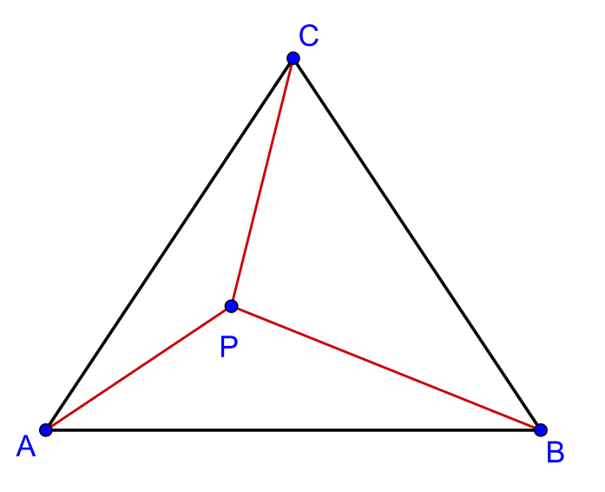

(b) Let $P$ be a point inside $∆ABC$ such that $a\overset{⃑}{PA}+b\overset{⃑}{PB}+c\overset{⃑}{PC}=\overset{⃑}{0}$ ,
find $\left[∆PBC\right]:\left[∆PCA\right]:\left[∆PAB\right]$.

(c) If $P$ be a point inside $∆ABC$ such that $\overset{⃑}{PA}+5\overset{⃑}{PB}+3\overset{⃑}{PC}=\overset{⃑}{0}$, find
$\left[∆ABC\right]:\left[ABPCA\right]$, where $ABPCA$ is the concave quadrilateral.

(a)
Method 1
$3\overset{⃑}{PA}+2\overset{⃑}{PB}+\overset{⃑}{PC}=\overset{⃑}{0}$
$3\left(-\overset{⃑}{AP}\right)+2\left(\overset{⃑}{AB}-\overset{⃑}{AP}\right)+\left(\overset{⃑}{AC}-\overset{⃑}{AP}\right)=\overset{⃑}{0}$
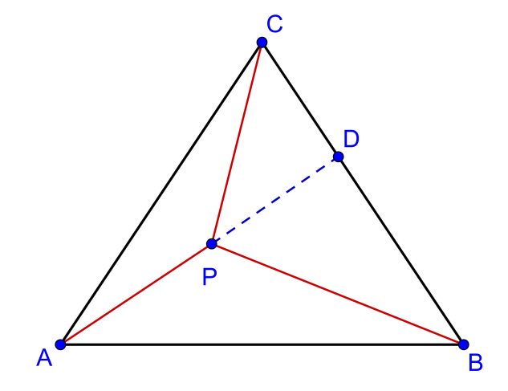
$\overset{⃑}{AP}=\frac{1}{6}\left(2\overset{⃑}{AB}+\overset{⃑}{AC}\right)$
Produce $AP$ to meet $BC$ at $D$.
Let $\overset{⃑}{AD}=λ\overset{⃑}{AP}=\frac{λ}{3}\overset{⃑}{AB}+\frac{λ}{6}\overset{⃑}{AC}$
Since $B,D,C$ are collinear, $\frac{λ}{3}+\frac{λ}{6}=1$ ,
$∴λ=2$
and $\overset{⃑}{AD}=\frac{2}{3}\overset{⃑}{AB}+\frac{1}{3}\overset{⃑}{AC}⟹BD:DC=1:2$
Also, $\overset{⃑}{AD}=2\overset{⃑}{AP}⟹AD=2AP⟹AP:PD=1:1$
$\left[∆PAB\right]=k$
$\left[∆PDB\right]=k$
$\left[∆ABD\right]=\left[∆PAB\right]+\left[∆PDB\right]=k+k=2k$
Since $BD:DC=1:2,$ $\left[∆PDC\right]=2k$ and $\left[∆ADC\right]=4k$
$\left[∆PBC\right]=\left[∆PDB\right]+\left[∆PDC\right]=k+2k=3k$
$\left[∆PCA\right]=\left[∆ADC\right]-\left[∆PDC\right]=4k-2k=2k$
$$∴ \left[∆PBC\right]:\left[∆PCA\right]:\left[∆PAB\right]=3k:2k:k=3:2:1$$

Method 2
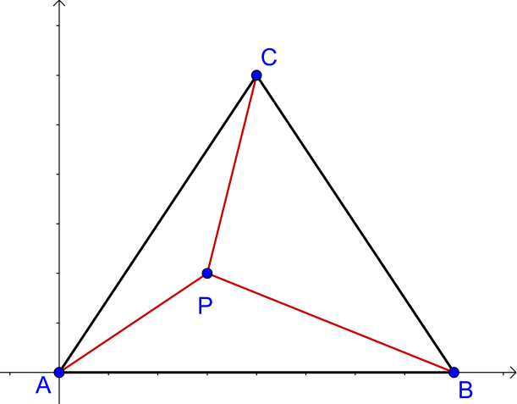
Place a coordinate system with $A$ as origin
and $\overset{⃑}{AB}$ along x-axis.

Since $3\overset{⃑}{PA}+2\overset{⃑}{PB}+\overset{⃑}{PC}=\overset{⃑}{0}$
Consider the y-cordinates,
${-3y}_{P}-2y_{P}+\left(y_{c}-y_{P}\right)=0$
$y_{C}={6y}_{P}$
Hence, $\left[∆PAB\right]=\frac{1}{6}\left[∆ABC\right]$
If we place a coordinate system with $B$ as origin and $\overset{⃑}{BC}$ along x-axis, we get: $\left[∆PBC\right]=\frac{1}{2}\left[∆ABC\right]$
If we place a coordinate system with $C$ as origin and $\overset{⃑}{CA}$ along x-axis, we get: $\left[∆PCA\right]=\frac{1}{3}\left[∆ABC\right]$
$$∴ \left[∆PBC\right]:\left[∆PCA\right]:\left[∆PAB\right]=3:2:1$$

Method 3

Let $\overset{⃑}{PA^{'}}=3\overset{⃑}{PA}, \overset{⃑}{PB^{'}}=2\overset{⃑}{PB} , \overset{⃑}{PC'}=\overset{⃑}{PC }$
Then $3\overset{⃑}{PA}+2\overset{⃑}{PB}+\overset{⃑}{PC}=\overset{⃑}{0}⟹ \overset{⃑}{PA^{'}}+\overset{⃑}{PB^{'}}+\overset{⃑}{PC^{'}}=0$

Hence, $P$ is the centroid of the $∆A'B'C'$.
$\left[∆PB'C'\right]:\left[∆PC'A'\right]:\left[∆PA'B'\right]=1:1:1⟹\left[∆PB'C'\right]=\left[∆PC'A'\right]=\left[∆PA'B'\right]=k$

$\frac{\left[∆PBC\right]}{\left[∆PB'C'\right]}=\frac{\frac{1}{2}PB×PC×sin ∠BPC}{\frac{1}{2}PB'×PC'×sin ∠BP'C'}=\frac{\frac{1}{2}PB×PC×sin ∠BPC}{\frac{1}{2}\left(2PB\right)×PC×sin ∠BPC}=\frac{1}{2}⟹\left[∆PB'C'\right]=\frac{1}{2}k$

Similarly, $\frac{\left[∆PCA\right]}{\left[∆PC'A'\right]}=\frac{1}{3} and \frac{\left[∆PAB\right]}{\left[∆PA'B'\right]}=\frac{1}{6}⟹\left[∆PCA\right]=\frac{1}{3}k and \left[∆PA'B'\right]=\frac{1}{6}k$
$∴ \left[∆PBC\right]:\left[∆PCA\right]:\left[∆PAB\right]=\frac{1}{2}k:\frac{1}{3}k:\frac{1}{6}k=3:2:1$

Method 4
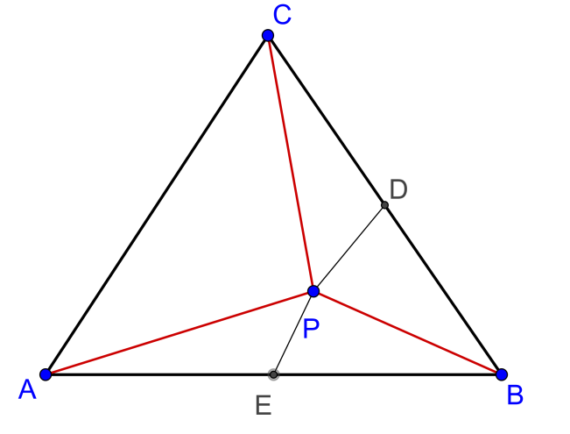
$$3\overset{⃑}{PA}+2\overset{⃑}{PB}+\overset{⃑}{PC}=\overset{⃑}{0}⟹\overset{⃑}{PB}+\overset{⃑}{PC}+2\left(\overset{⃑}{PA}+\overset{⃑}{PB}\right)=0$$
Construct the mid-point of $BC$ as $D$.
Then $\overset{⃑}{PB}+\overset{⃑}{PC}=2\overset{⃑}{PD}$
Construct the mid-point of $AB$ as $E$.
Then $\overset{⃑}{PA}+\overset{⃑}{PB}=2\overset{⃑}{PE}$
Hence we can get $2\overset{⃑}{PD}+4\overset{⃑}{PE}=0$
$$∴ \overset{⃑}{PD}=2\overset{⃑}{EP}$$
Then $D,P,E$ is a straight line and $PD:EP=2:1$

Let $\left[∆PEB\right]=k$, then $\left[∆PDB\right]=2k$

Since $D,E$ are mid-points of $BC$ and $AB$ respectively,
$\left[∆APE\right]=k,\left[∆CPD\right]=2k$
Hence $\left[∆PAB\right]=2k, \left[∆PBC\right]=4k$

By Mid-point Theorem, $AC=2ED$ and note that $∆EBD\sim ∆EDB$
Since $\left[∆EDB\right]=3k,\left[∆ABC\right]=12k$,
$$\left[∆PCA\right]=12k-4k-2k=6k$$

$∴ \left[∆PBC\right]:\left[∆PCA\right]:\left[∆PAB\right]=6k:4k:2k=3:2:1$

Method 5 Note: $\left|\begin{matrix}x_{1} & x_{2} \\ y_{1} & y_{2}\end{matrix}\right|=x_{1}y_{2}-x_{2}y_{1}$

Let $P$ be the origin and $\overset{⃑}{PA}=x_{1}i+y_{1}j$ , $\overset{⃑}{PB}=x_{2}i+y_{2}j$ , $\overset{⃑}{PC}=x_{3}i+y_{3}j$
$$3\overset{⃑}{PA}+2\overset{⃑}{PB}+\overset{⃑}{PC}=\overset{⃑}{0}⟹\left(3x_{1}+2x_{2}+x_{3}\right)i+\left(3y_{1}+2y_{2}+y_{3}\right)j=0$$
$$⟹\left\{\begin{aligned}3x_{1}+2x_{2}+x_{3}=0 \\ 3y_{1}+2y_{2}+y_{3}=0\end{aligned}\right.⟹\left|\begin{matrix}x_{2} & x_{3} \\ y_{2} & y_{3}\end{matrix}\right|:\left|\begin{matrix}x_{3} & x_{1} \\ y_{3} & y_{1}\end{matrix}\right|:\left|\begin{matrix}x_{1} & x_{2} \\ y_{1} & y_{2}\end{matrix}\right|=3:2:1$$
$$∴ \left[∆PBC\right]:\left[∆PCA\right]:\left[∆PAB\right]=\frac{1}{2}\left|\begin{matrix}x_{2} & x_{3} \\ y_{2} & y_{3}\end{matrix}\right|:\frac{1}{2}\left|\begin{matrix}x_{3} & x_{1} \\ y_{3} & y_{1}\end{matrix}\right|:\frac{1}{2}\left|\begin{matrix}x_{1} & x_{2} \\ y_{1} & y_{2}\end{matrix}\right|=3:2:1$$

Method 6

There is a one-to-one correspondence between vector and complex number.
For any vector $\overset{⃑}{v}=xi+yj$, there is a complex number $z=x+yi$.

The problem then becomes:
Take $P$ to be the origin of the complex plane and $A\left(z_{1}\right), B\left(z_{2}\right) and C\left(z_{3}\right)$, and
$3z_{1}+2z_{2}+z_{3}=0$ , find $\left[∆PBC\right]:\left[∆PCA\right]:\left[∆PAB\right]$, where $\left[∆PAB\right]$ represents the area of the $∆PAB$.

Since $3z_{1}+2z_{2}+z_{3}=0$, we have the conjugate equation $3\overline{z_{1}}+2\overline{z_{2}}+\overline{z_{3}}=0$.
Hence $\left(z_{2}\overline{z_{3}}-z_{3}\overline{z_{2}}\right):\left(z_{3}\overline{z_{1}}-z_{1}\overline{z_{3}}\right):\left(z_{1}\overline{z_{2}}-z_{2}\overline{z_{1}}\right)=3:2:1$.

By the area formula in complex number, we have
$\left[∆PBC\right]:\left[∆PCA\right]:\left[∆PAB\right]=\frac{i}{4}\left|\begin{matrix}1 & 1 & 1 \\ 0 & z_{2} & z_{3} \\ 0 & \overline{z_{2}} & \overline{z_{3}}\end{matrix}\right|:\frac{i}{4}\left|\begin{matrix}1 & 1 & 1 \\ 0 & z_{3} & z_{1} \\ 0 & \overline{z_{3}} & \overline{z_{1}}\end{matrix}\right|:\frac{i}{4}\left|\begin{matrix}1 & 1 & 1 \\ 0 & z_{1} & z_{2} \\ 0 & \overline{z_{1}} & \overline{z_{2}}\end{matrix}\right|$
$=\left(z_{2}\overline{z_{3}}-z_{3}\overline{z_{2}}\right):\left(z_{3}\overline{z_{1}}-z_{1}\overline{z_{3}}\right):\left(z_{1}\overline{z_{2}}-z_{2}\overline{z_{1}}\right)$
$=3:2:1$

(b) Place a coordinate system with $A$ as origin and $\overset{⃑}{AB}$
along x-axis.

Since $a\overset{⃑}{PA}+b\overset{⃑}{PB}+c\overset{⃑}{PC}=\overset{⃑}{0}$
Consider the y-cordinates,
${-ay}_{P}-by_{P}+c\left(y_{c}-y_{P}\right)=0$
$y_{C}={\frac{c}{a+b+c}y}_{P}$
Hence, $\left[∆PAB\right]=\frac{c}{a+b+c}\left[∆ABC\right]$
If we set a coordinate system with $B$ as origin and $\overset{⃑}{BC}$ along x-axis, then: $\left[∆PBC\right]=\frac{a}{a+b+c}\left[∆ABC\right]$
If we set a coordinate system with $C$ as origin and $\overset{⃑}{CA}$ along x-axis, then: $\left[∆PCA\right]=\frac{b}{a+b+c}\left[∆ABC\right]$
$$∴ \left[∆PBC\right]:\left[∆PCA\right]:\left[∆PAB\right]=\frac{a}{a+b+c}:\frac{b}{a+b+c}:\frac{c}{a+b+c}=a:b:c$$

(c) $\overset{⃑}{PA}+5\overset{⃑}{PB}+3\overset{⃑}{PC}=\overset{⃑}{0}$, by (b),
$$\left[∆PBC\right]:\left[∆PCA\right]:\left[∆PAB\right]=1:5:3$$
$\left[∆PBC\right]=k, \left[∆PCA\right]=5k, \left[∆PAB\right]=3k$

Therefore, $\left[∆ABC\right]=k+5k+3k=9k$
and $\left[ABPCA\right]=3k+5k=8k$

$\left[∆ABC\right]:\left[ABPCA\right]=9k:8k=9:8$

Yue Kwok Choy
1-3-2016

Method 6 of part (a) added on 10-3-16

