Polygons

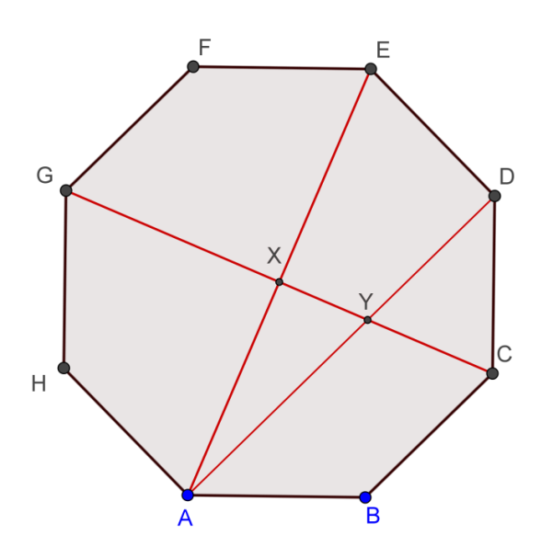
1. (Warm-up on Pythagoras Theorem)
Given a regular octagon ABCDEFGH with
sides 2 cm.

(a) If AE intersects CG at X.
Find the length of AX.
(b) If AD cuts CG at Y.
Find the length of XY.

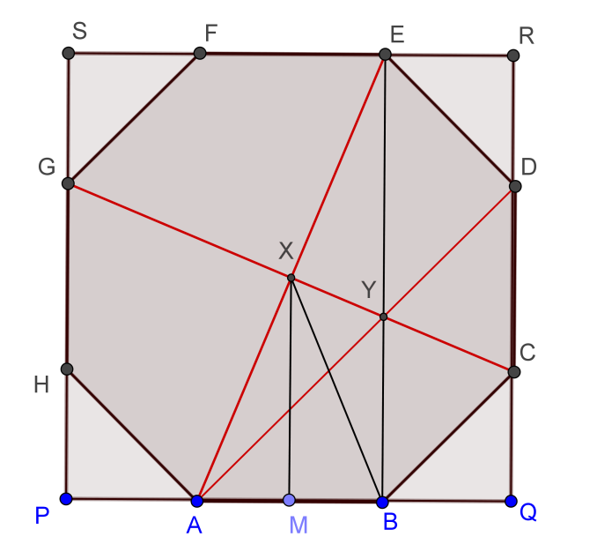
1. (a) Draw a square outside touching the sides of the octagon as in the diagram.
It can be seen that X is the centre of both
the octagon and the square.

By Pythagoras Theorem on $∆PAH$,
$PA=PH=\sqrt{2}$
$PQ=PA+AB+BQ=\sqrt{2}+2+\sqrt{2}$
$=2+2\sqrt{2}$
So the side of the square is $2+2\sqrt{2}$.
By Pythagoras Theorem on $∆ABE$,
$AE=\sqrt{2^{2}+{2+\left(2\sqrt{2}\right)}^{2}}=\sqrt{8 \sqrt{2}+16}$
$AX=\frac{1}{2}AE=\frac{1}{2}\sqrt{8 \sqrt{2}+16}=\sqrt{2 \sqrt{2}+4}≈2.6131259297528$ cm

(b) Note that $∆ABY$ is right angled and $∠BAY=45°$.
By Pythagoras Theorem, $AY=\sqrt{8}$
Note that AE is perpendicular to CG.
Apply Pythagoras Theorem on $∆AXY$ .
$XY=\sqrt{{\left(\sqrt{8}\right)}^{2}-{\left(\sqrt{2 \sqrt{2}+4}\right)}^{2}}=\sqrt{4-2 \sqrt{2}}≈1.0823922002924$ cm

2. A dodecagon of is placed inside a circle of radius 1 cm, and the twelve dividing points are joined to the circle's centre, producing twelve rays. Starting from $P_{1}$ a segment is drawn perpendicular to the next ray $OP_{2}$ in the anti-clockwise sense; and from the foot of this perpendicular another perpendicular segment is drawn to the next ray, and so on forever.
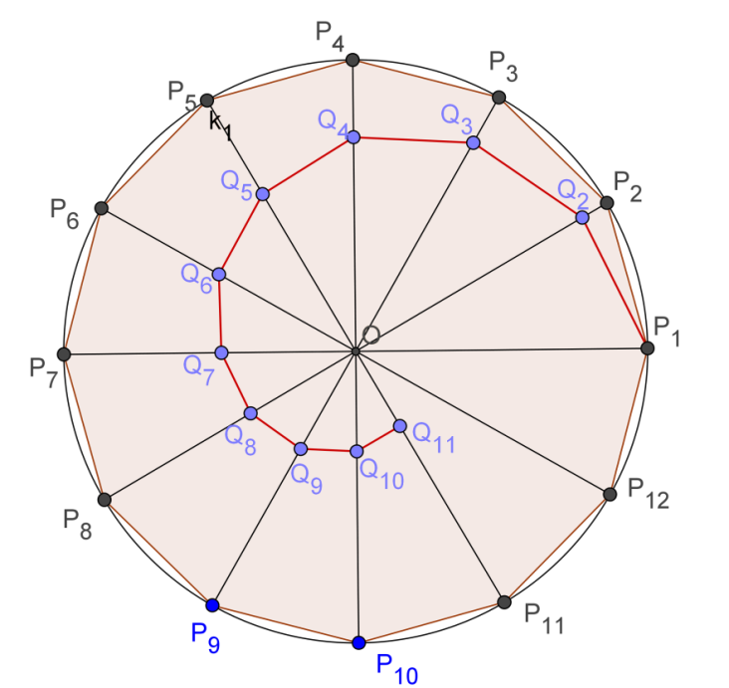
Taking ${Q_{1}=P}_{1}$ .

(a) Find the limit of the sum of the lengths of these segments:
$Q_{1}Q_{2}+Q_{2}Q_{3}+Q_{3}Q_{4}+Q_{4}Q_{5}+…$
$=\sum_{k=1}^{∞}{Q_{k}Q_{k+1}}$

(b) Find the limit of the area of the triangles :
$∆OQ_{1}Q_{2}+∆OQ_{2}Q_{3}+∆OQ_{3}Q_{4}+…$
$=\sum_{k=1}^{∞}{∆OQ_{k}Q_{k+1}}$.

(c) (For more able students)
Instead of starting with the circle divided into twelve equal parts, we now to divide it into n equal parts. Let ${∠Q}_{1}OQ_{2}=α$.

(i) Find the sum of the lengths: $\sum_{k=1}^{∞}{Q_{k}Q_{k+1}}$
(ii) Find the limit of the area of the triangles : $\sum_{k=1}^{∞}{∆OQ_{k}Q_{k+1}}$

2. (a) Consider the triangle $∆OQ_{k}Q_{k+1}$ .
$∠OQ_{k}Q_{k+1}=60°,∠Q_{k}OQ_{k+1}=30°,∠Q_{k}Q_{k+1}O=90°$
Let $OQ_{k}=r_{k}, OQ_{k+1}=r_{k+1}$.
Then $r_{k+1}=r_{k}\cos{30°}=\frac{\sqrt{3}}{2}r_{k}$
$Q_{k}Q_{k+1}=r_{k}\sin{30°}=\frac{1}{2}r_{k}$
$Q_{k+1}Q_{k+2}=\frac{1}{2}r_{k+1}=\frac{1}{2}\left(\frac{\sqrt{3}}{2}r_{k}\right)=Q_{k}Q_{k+1}\frac{\sqrt{3}}{2}$
Sum of the lengths:
$\sum_{k=1}^{∞}{Q_{k}Q_{k+1}}=Q_{1}Q_{2}+Q_{2}Q_{3}+Q_{3}Q_{4}+Q_{4}Q_{5}+…$
$=\frac{1}{2}+\frac{1}{2}\left(\frac{\sqrt{3}}{2}\right)+\frac{1}{2}{\left(\frac{\sqrt{3}}{2}\right)}^{2}+\frac{1}{2}{\left(\frac{\sqrt{3}}{2}\right)}^{3}+…$ , which is an infinite geometric series
$=\frac{1}{2}\left(\frac{1}{1-\frac{\sqrt{3}}{2}}\right)$ , where the common ratio $\frac{\sqrt{3}}{2}<1$.
$=\frac{1}{2-\sqrt{3}}=2+\sqrt{3}≈3.7320508075689$ cm
(b) $OQ_{k+1}=r_{k+1}=\frac{\sqrt{3}}{2}r_{k}$
The limit of the area of the triangles : $∆OQ_{1}Q_{2}+∆OQ_{2}Q_{3}+∆OQ_{3}Q_{4}+…$
$=\frac{1}{2}OQ_{2}×Q_{1}Q_{2}+\frac{1}{2}OQ_{3}×Q_{2}Q_{3}+\frac{1}{2}OQ_{4}×{Q_{3}Q}_{4}+…$
$=\frac{1}{2}\left(\frac{\sqrt{3}}{2}\right)\left(\frac{1}{2}\right)+\frac{1}{2}{\left(\frac{\sqrt{3}}{2}\right)}^{2}\left[\frac{1}{2}\left(\frac{\sqrt{3}}{2}\right)\right]+\frac{1}{2}{\left(\frac{\sqrt{3}}{2}\right)}^{3}\left[\frac{1}{2}{\left(\frac{\sqrt{3}}{2}\right)}^{2}\right]+\frac{1}{2}{\left(\frac{\sqrt{3}}{2}\right)}^{4}\left[\frac{1}{2}{\left(\frac{\sqrt{3}}{2}\right)}^{3}\right]+…$
$={\left(\frac{1}{2}\right)}^{2}\left(\frac{\sqrt{3}}{2}\right)+{\left(\frac{1}{2}\right)}^{2}{\left(\frac{\sqrt{3}}{2}\right)}^{3}+{\left(\frac{1}{2}\right)}^{2}{\left(\frac{\sqrt{3}}{2}\right)}^{5}+{\left(\frac{1}{2}\right)}^{2}{\left(\frac{\sqrt{3}}{2}\right)}^{7}+…$
$={\left(\frac{1}{2}\right)}^{2}\left(\frac{\sqrt{3}}{2}\right)\left(\frac{1}{1-{\left(\frac{\sqrt{3}}{2}\right)}^{2}}\right)$, where the common ratio ${\left(\frac{\sqrt{3}}{2}\right)}^{2}<1$
$=\frac{\sqrt{3}}{2}≈0.8660254037844$ cm
(c) (i) Consider the triangle $∆OQ_{k}Q_{k+1}$ .
$∠Q_{k}OQ_{k+1}=α, ∠Q_{k}Q_{k+1}O=90°$
Let $OQ_{k}=r_{k}, OQ_{k+1}=r_{k+1}$.
Then $r_{k+1}=r_{k}\cos{α}$
$Q_{k}Q_{k+1}=r_{k}\sin{α}$
$Q_{k+1}Q_{k+2}={r_{k+1}\sin{α}=r}_{k}\sin{α}\cos{α}=Q_{k}Q_{k+1}\cos{α}$
Sum of the lengths:
$\sum_{k=1}^{∞}{Q_{k}Q_{k+1}}=Q_{1}Q_{2}+Q_{2}Q_{3}+Q_{3}Q_{4}+Q_{4}Q_{5}+…$
$=\left(\sin{α}\right)+\left(\sin{α}\right)\left(\cos{α}\right)+\left(\sin{α}\right){\left(\cos{α}\right)}^{2}+\left(\sin{α}\right){\left(\cos{α}\right)}^{3}+…$
$=\left(\sin{α}\right)\frac{1}{1-\cos{α}}=\frac{\sin{α}}{1-\cos{α}}$

(ii) Note that : $OQ_{k+1}=r_{k+1}=r_{k}\cos{α}$
The limit of the area of the triangles :
$∆OQ_{1}Q_{2}+∆OQ_{2}Q_{3}+∆OQ_{3}Q_{4}+…$
$=\frac{1}{2}OQ_{2}×Q_{1}Q_{2}+\frac{1}{2}OQ_{3}×Q_{2}Q_{3}+\frac{1}{2}OQ_{4}×{Q_{3}Q}_{4}+…$
$=\frac{1}{2}\cos{α}\sin{α}+\frac{1}{2}{\left(\cos{α}\right)}^{2}\left[\sin{α}{\cos{α}}\right]+\frac{1}{2}{\left(\cos{α}\right)}^{3}\left[\sin{α}{\left(\cos{α}\right)}^{2}\right]$
$$+\frac{1}{2}{\left(\cos{α}\right)}^{4}\left[\sin{α}{\left(\cos{α}\right)}^{3}\right]+…$$
$=\frac{1}{2}\sin{α}cos{α}+\frac{1}{2}{\sin{α}\left(\cos{α}\right)}^{3}+\frac{1}{2}{\sin{α}\left(\cos{α}\right)}^{5}+\frac{1}{2}{\sin{α}\left(\cos{α}\right)}^{7}+…$
$=\frac{1}{2}\sin{α}cos{α}\frac{1}{1-{\left(\cos{α}\right)}^{2}}=\frac{\sin{α}cos{α}}{2{\left(\sin{α}\right)}^{2}}=\frac{\cos{α}}{2\sin{α}}=\frac{1}{2\tan{α}}$
Yue Kwok Choy
7/3/2017

