Mooncakes
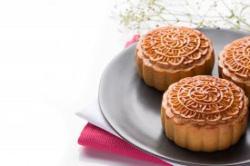
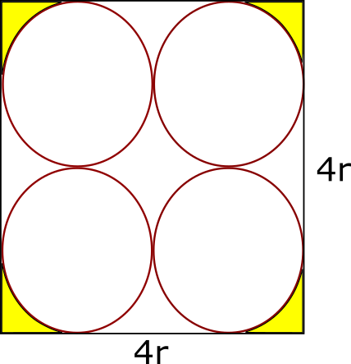
(a) A square box of side $d$ contains 4 moon-cakes each of radius $r$ is shown in the right diagram.
Find the area shaded in yellow in terms of $d$ .

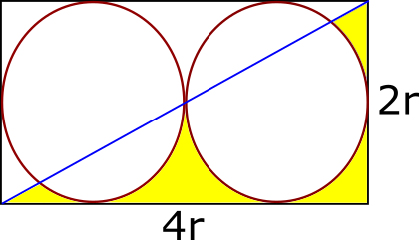
(b) (i) A rectangular moon-cake box contains two moon-cakes, each of radius r.
A diagonal is drawn as shown in the right.
Find the total area of the parts shaded yellow in terms of r.

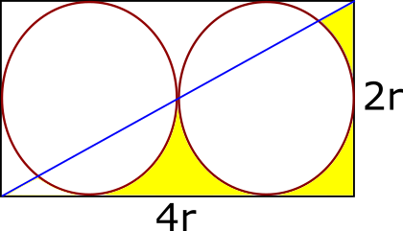
(ii) Find the total area of the parts shaded yellow in terms of r.
(Note that a small piece of area in yellow in the lower left corner is removed)

(a) The area shaded in yellow $=\frac{4}{16}\left(d^{2}-4r^{2}\right)=\frac{1}{4}\left[d^{2}-4{\left(\frac{d}{4}\right)}^{2}\right]=\underline{\underline{\frac{3 d^{2}}{16}}}$

(b) (i)
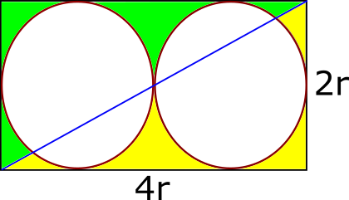
Total area shaded in yellow = total area shaded in green
Therefore, total area shaded in yellow
$$=\frac{1}{2}\left[area of rectangle-2\left(area of one circle\right)\right]$$
$$=\frac{1}{2}\left[\left(4r\right)\left(2r\right)-2\left(πr^{2}\right)\right]=4r^{2}-πr^{2}=\underline{\underline{\left(4-π\right)r^{2}}}$$

(b) (ii) We concentrate on the left square and find the lower left area that is removed.
(in green)
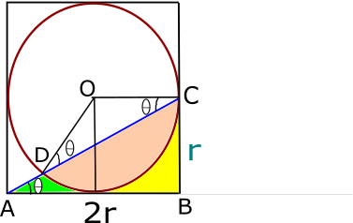
Area in green = area of ΔABC – area in yellow – area in orange
Area of ΔABC $=\frac{1}{2}×2r×r=r^{2}$
Area in yellow $=\frac{1}{4}×\left(area of square-area of circle\right)$
$=\frac{1}{4}×\left(4r^{2}-πr^{2}\right)=\frac{1}{4}\left(4-π\right)r^{2}$
$∠BAC=θ$ , then $∠OCD=∠ODC=θ$, $∠DOC=π-2θ$
$\tan{θ=\frac{CB}{AB}=\frac{r}{2r}}=\frac{1}{2}$
Also by Pythagoras Theorem, $AC=\sqrt{5}r$, $\sin{θ=\frac{r}{\sqrt{5}r}}=\frac{1}{\sqrt{5}}, \cos{θ}=\frac{2r}{\sqrt{5}r}=\frac{2}{\sqrt{5}}$
Area of ΔDOC $=\frac{1}{2}r^{2}\sin\left(π-2θ\right)=\frac{1}{2}r^{2}\sin{2θ=\frac{1}{2}r^{2}\left(2 sin θ cos θ\right)}$
$=\frac{1}{2}r^{2}\left(2 ×\frac{1}{\sqrt{5}}× \frac{2}{\sqrt{5}}\right)=\frac{2}{5}r^{2}$
Area of segment in orange = Area of sector – area of ΔDOC
$=\frac{1}{2}r^{2}\left(π-2θ\right)-\frac{2}{5}r^{2}=\frac{1}{2}{πr}^{2}-\frac{2}{5}r^{2}-r^{2}θ=\frac{1}{2}{πr}^{2}-\frac{2}{5}r^{2}-r^{2}\tan^{-1}{\frac{1}{2}}$
Area in green = area of ΔABC – area in yellow – area in orange
$r^{2}-\frac{1}{4}\left(4-π\right)r^{2}-\left(\frac{1}{2}{πr}^{2}-\frac{2}{5}r^{2}-r^{2}\tan^{-1}{\frac{1}{2}}\right)=\frac{2 r^{2}}{5}{-\frac{π r^{2}}{4}+r}^{2}\tan^{-1}{\frac{1}{2}}$

Lastly, the total area of the parts shaded yellow
= area in part (a) - missing small piece of area in green calculated above
$=\left(4-π\right)r^{2}-\left[\frac{2 r^{2}}{5}{-\frac{π r^{2}}{4}+r}^{2}\tan^{-1}{\frac{1}{2}}\right]$
$=\underline{\underline{\frac{18 r^{2}}{5}-\frac{3π r^{2}}{4}-r^{2}\tan^{-1}{\frac{1}{2}}}}$

Yue Kwok Choy
15/9/2016

