Conics

Given that the ellipse $\frac{x^{2}}{t+1}+\frac{y^{2}}{t-1}=1$ is tangential to the hyperbola $xy=1$ and $t>1$.
Find the value of t.
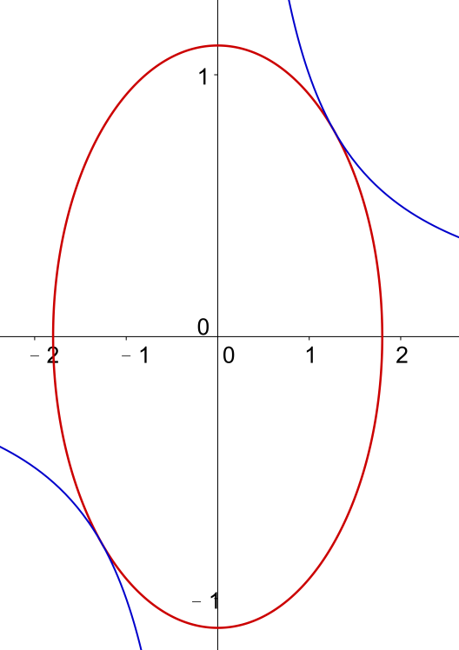

Method 1
$xy=1⟹y=\frac{1}{x}⟹\frac{dy}{dx}=-\frac{1}{x^{2}}$
$\frac{x^{2}}{t+1}+\frac{y^{2}}{t-1}=1⟹\frac{2x}{t+1}+\frac{2y}{t-1}\frac{dy}{dx}=0⟹\frac{dy}{dx}=-\frac{x\left(t-1\right)}{y\left(t+1\right)}$
Since $\frac{x^{2}}{t+1}+\frac{y^{2}}{t-1}=1$ is tangential to the hyperbola $xy=1$, we have
$-\frac{1}{x^{2}}=-\frac{x\left(t-1\right)}{y\left(t+1\right)}⟹y=\frac{t-1}{t+1}x^{3} ….(1)$
Substitute (1) in $xy=1$, $\frac{t-1}{t+1}x^{4}=1⟹x=±\sqrt[4]{\frac{t+1}{t-1}}$ , since $t>1$
Substitute in (1), $y=\frac{t-1}{t+1}{\left(±\sqrt[4]{\frac{t+1}{t-1}}\right)}^{3}=±\sqrt[4]{\frac{t-1}{t+1}}$
The points of contact of the given ellipse and hyperbola is $\left(±\sqrt[4]{\frac{t+1}{t-1}},±\sqrt[4]{\frac{t-1}{t+1}}\right)$
Substitute this points in the equation of the ellipse $\frac{x^{2}}{t+1}+\frac{y^{2}}{t-1}=1$,
$\frac{{\left(±\sqrt[4]{\frac{t+1}{t-1}}\right)}^{2}}{t+1}+\frac{{\left(±\sqrt[4]{\frac{t-1}{t+1}}\right)}^{2}}{t-1}=1⟹\frac{1}{\sqrt{t^{2}-1}}+\frac{1}{\sqrt{t^{2}-1}}=1⟹\frac{2}{\sqrt{t^{2}-1}}=1⟹t=\sqrt{5}$, since $t>1$.
Method 2
$xy=1⟹y=\frac{1}{x}$
Substitute in $\frac{x^{2}}{t+1}+\frac{y^{2}}{t-1}=1$, $\frac{x^{2}}{t+1}+\frac{{\left(1/x\right)}^{2}}{t-1}=1$
$\left(t-1\right){\left(x^{2}\right)}^{2}-\left(t^{2}-1\right)\left(x^{2}\right)+\left(t+1\right)=0 ….(1)$

Since $\frac{x^{2}}{t+1}+\frac{y^{2}}{t-1}=1$ is tangential to the hyperbola $xy=1$, we have
$∆ of (1)={\left(t^{2}-1\right)}^{2}-4\left(t-1\right)\left(t+1\right)=0$
$${\left(t^{2}-1\right)}^{2}-4\left(t-1\right)\left(t+1\right)=0$$
$∴ t=\sqrt{5}$ , since $t>1$.

Method 3
The parametric form of $\frac{x^{2}}{t+1}+\frac{y^{2}}{t-1}=1$ is $\left\{\begin{aligned}x=\sqrt{t+1}\cos{θ} \\ y=\sqrt{t-1}\sin{θ}\end{aligned}\right.$, $0≤θ<2π$ .
Substitute in $xy=1$ , we get $\left(\sqrt{t+1}\cos{θ}\right)\left(\sqrt{t-1}\sin{θ}\right)=1⟹\sin{2θ=\frac{2}{\sqrt{t^{2}-1}}}$ .
Since $\frac{x^{2}}{t+1}+\frac{y^{2}}{t-1}=1$ is tangential to the hyperbola $xy=1$, we have
$\sin{2θ=1⟹}\frac{2}{\sqrt{t^{2}-1}}=1⟹t=\sqrt{5}$ , since $t>1$.
(For $\sin{2θ=1}$, we have one root. For other values of $\sin{2θ}$ , we can get two roots or no root.)

Yue Kwok Choy
13-6-2016

